Business Case: Swiggy’s funnel analysis (Year 2019)

At the very core, orders received is a function of traffic and conversion.

Orders = Traffic × Conversion

So, when the orders fluctuate, it must be one of these two or both that we need to investigate.

We are investigating Week Over Week (WoW) fluctuations in orders and trying to understand reasons behind the same. For sake of simplicity, we’re only considering significant fluctuations.

* Significant change is defined as a change more than 20% i.e., +/- 20%
* Changes smaller than +/- 20% are considered as marginal and ignored
* Number 20 has nothing special and can be changed as per the business needs and problem that we’re trying to solve

Let’s look now on a broader level, how orders are changing vis a vis change in traffic and conversion.

Just from the above graph, it is visible that orders are changing with respect to either traffic or conversion in a positive correlation. And often with respect to conversion than traffic.

Let’s take a closer look at what’s happening in detail:

*(Same analysis is available in the excel file submitted as well)*

This data is for 37 significant days over the year, where change in orders is significant.

Let’s see how traffic, conversion, and both (overall) change are contributing towards change in orders across these 37 dates.

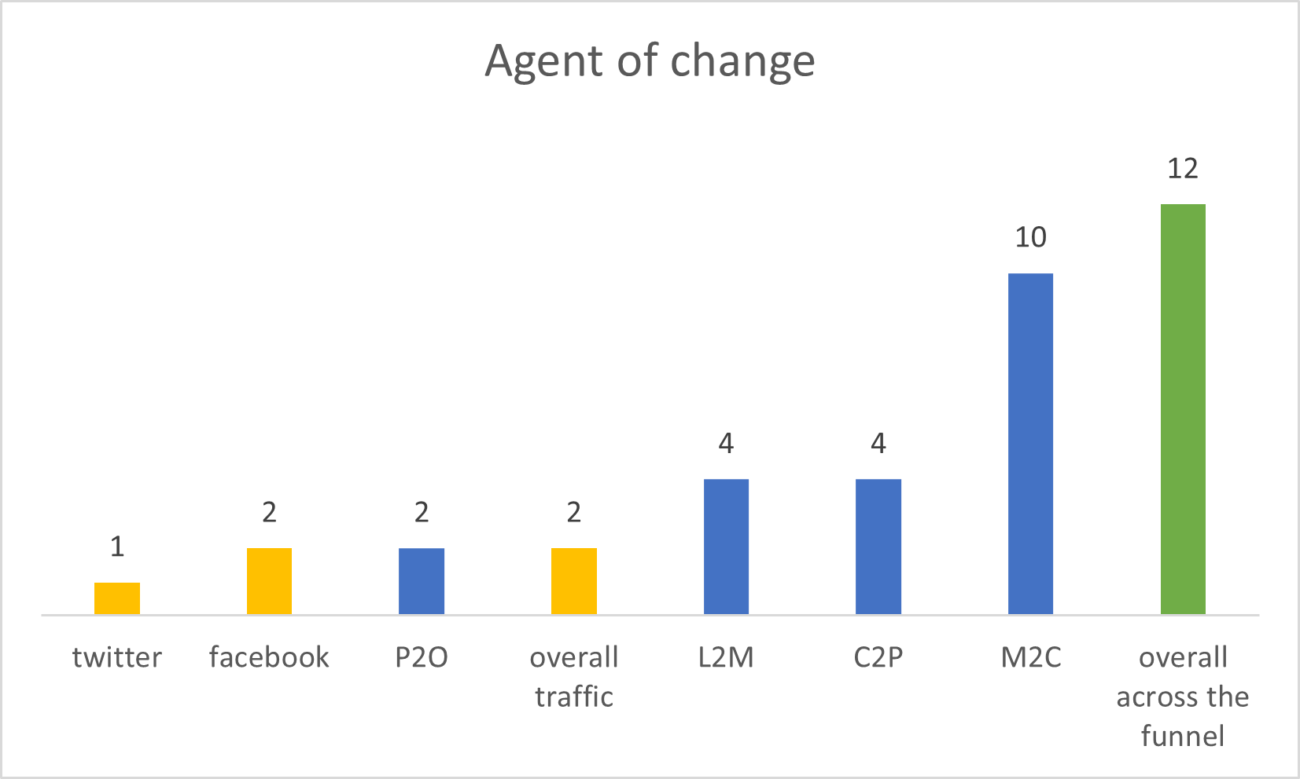

|  |  |  |
| --- | --- | --- |
| Color Code | Agent | Count |
| **Yellow** | Traffic | 5 |
| **Blue** | Conversion | 20 |
| **Green** | Both (overall change) | 12 |
|  | Total | 37 |

So, we’ve now established with help of data that orders are changing more often with respect to conversion than traffic.

Suggestions to effectively leverage these factors to minimize drop and maximize hike in the orders:

1. Channel specific traffic drops can be minimized by targeted marketing in that traffic channel
2. Channel specific traffic hikes can be maximized in 2 ways: (A) targeted marketing in that traffic channel (B) analyzing traffic on that channel and replicating that pattern in other traffic channels
3. Further investigation for overall drops/hikes either in traffic or across the funnel with no apparent specific reason to understand business in a better, more detailed manner
4. Further investigation for understanding changes in “average cost for two” and taking steps to minimize the same
5. Further investigation for understanding changes in “average packaging charges” and taking steps to minimize the same
6. Further investigation for understanding changes in “out of stock items” and taking steps to minimize the same
7. Further investigation for understanding changes in “restaurant availability” and taking steps to minimize the same
8. Strengthening payment systems for handling more traffic without any failures; aiming 6-sigma efficiency in payment success rate
9. Since currently there’s no strong correlation between orders and “number of images available of a restaurant”, we can try experimenting this factor to see whether it affects orders or not and leverage it accordingly
10. “Weekend rush” is a recurring and expected theme across the data, a detailed business wide investigation should be done to handle weekend rush effectively and maximize orders during the weekend